Title (Arial 12pt bold, small caps)

Author¹, Author ², Author³ (Arial 10pt italic)
1 Institute/Company, Place (Arial 9pt)
2 Institute/Company, Place (Arial 9pt)

Abstract (Arial 11pt bold, small caps)
The abstract contains a short summary and should not be longer than 10 to 15 lines. (Arial 10pt)

- Introduction (Arial 11pt bold, small caps)
This template serves as a reference for the preparation of a manuscript for the REGWA conference proceedings. It contains information on uniform formatting to facilitate the editorial processing of all contributions and to ensure a uniform appearance.

Your contribution should preferably not exceed 8 pages. The contribution will be published online.

You can use this template to create your paper directly by replacing the text in this template with your own.

Please submit the paper as a Word and as a pdf document.

- Formatting (Arial 11pt bold, small caps)
The paper size is DIN A4. Publication in the conference proceedings will also be in DINA4 format. (Arial 10pt). Choose the following margins:
- top 3.5 cm, right 2.5 cm, left 2.5 cm, bottom 2.5 cm, gutter 0 cm.
- Header: Distance from page margin: 1.5 cm
- Footer: Distance from page margin: 0.5 cm

The font used is Arial:
- for the body of the text, font size 10pt
- for the headings font size 11pt
- Line spacing: 1.15
- TABLES, FIGURES AND FORMULAE (Arial 11pt bold, small caps)
3.1 Graphics, photos and illustrations
Images must be reproducible, whereby the resolution should be at least 300 dpi and max. 600 dpi. Please place illustrations in the desired position in the size to be reproduced. Illustrations are to be provided with a caption below the illustration and arranged in a centred position.
The text refers to the illustrations.

Example illustration:

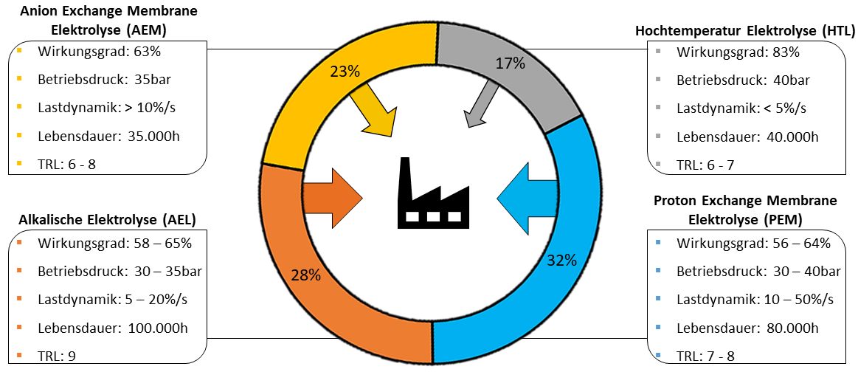
Figure 1: Comparison of electrolysis technologies

3.2 Tables (Arial 11pt)
Tables should also be centred and otherwise individually formatted. The font of the table should be the same as in the body text (Arial). Unlike illustrations, tables are given a heading. The text refers to the tables presented.
Example table:
Table 1: Overview of anthropogenic greenhouse gases (Arial 10pt bold)
Spurengas | Konzentration | Verweildauer in Jahren | Treibhaus-potenzial
CO₂ | 405 ppm | 30-1000 | 1
CH₄ | 1850 ppb | 9,1 | 25
N₂O | 330 ppb | 131 | 298

3.3 Formulae (Arial 11pt)
Formulae should be centred. The numbering of the formula is right-aligned. The text of the paper refers to the formulae given. The font of the formulae should be the same as in the body text (Arial).
E = mc² (1)

- BIBLIOGRAPHY (Arial 11pt bold, small caps)
Cited sources are presented in a bibliography according to IEEE citation rules. (Arial 10pt)
[1] Initial of first name. Surname, title of publication, edition, place, publisher, year.

